Report on Course Implementation

Name of institution King Mongkut's University of Technology North Bangkok
Campus/ Faculty/ Program …………………………………………………………………………………………….

Section 1: General Information
1. Course code and course title
..................................................................................................................................................
2. Total credits
........... X credits (x-x-x) .............................................................................................................................
3. Curriculum and course category:
Curriculum: e.g. (Bachelor of ………in ……)……………………………………
Course category: (e.g. general education, required, major elective, free elective)

4. Course coordinator/ instructors
Course coordinator ..............................................................................
Instructors ..............................................................................
5. Semester/ year of study
………………………………………………………………………………
6. Pre-requisite (if any)
………………………………………………………………………………
7. Co-requisites (if any)
……………………………………………………………………………….
8. Information for quality assurance in education
This course shows evidence of:
Development of implementation from previous practices, e.g. the improvement of instruction,
course content, content classification and methods used for learning assessment
Involvement from professional bodies/ external agencies in instruction; thus enhancing
student academic and professional experiences
Integration of research or creative activities with instruction; use of research-based learning
management; knowledge management practices for learning improvement
Integration of academic services and course implementation
Combination of cultural heritage preservation efforts into instruction or student activities

9. Date of latest revision
........................................................

Section 2: Course Learning Outcomes (CLOs)
Students should be able to: (see OBE3, section 2.4)
CLO 1. Explain …………………
CLO 2. Analyze ………………….
CLO 3. Solve problems …………
CLO 4. Apply………………………
CLO 5. Perform…………………….
(Items can be included or deleted as appropriate)

Section 3: Course Implementation
- Outcomes of implementation process for learning efficiency

A. Preparation of all those involved
Preparation | Outcomes |  |  | Improvement plan
Preparation | implemented as planned | Deviation from plan, specify | No implementation | Improvement plan
- Student preparation
2. Advisor/ supervisor/ mentor preparation
3. Preparation of intern mentor at work place

B. Support for enhancing learning effectiveness
Support domains | Outcomes
Support domains | Implemented as planned | No implementation | Implemented as planned
1. Up-to-date student manual | Specify the academic year of latest revision
2. Adopting IT system | Indicate the IT system used for promoting instructional efficiency
3. Problem acknowledgement practice | Explain
4. Student counseling system
5. Others (specify)

- Any changes in the management of the internship program, compared to the determined plan (OBE4), if some adjustments occur

A. Specify whether the internship is consistent with the original plan or not. Indicate impacts of alteration (positive or negative impacts) and recommendations for future directions.
Discrepancies between the internship training and the plan specified in OBE4) | Progress as planned | Deviation from the plan and impacts  (positive/ negative) |  |  | Factors contributing to discrepancies / recommendations for future planning
 | Progress as planned | major | moderate | small
1. activities and assignments
2. facilities provided for students
3. planned workplace
4. other changes (if any)

- Learning Outcome Evaluation
Procedure | Is there any plan? |  | Improvement guidelines
Procedure | Yes | No | Improvement guidelines
- Using appropriate instruments to evaluate learning outcomes
A. Rubrics
B. Others, specify..............
- Those involved in conducting the evaluation
A. Instructors/ mentors from workplace
B. Instructors in charge of the course
C. Peers/ classmates
D. Others, specify..............
- Providing feedback to individual students
- Evaluation results are developed to create a plan to assist student
- Well-defined assessment criteria
- Using a standards-based grading system
criterion referenced evaluation
norm referenced evaluation
others, specify..............
- Verification of assessment process and learning outcomes

Section 4: Assessment Overview

1. Evaluation outcomes (Capture the screenshot from the course evaluation form)
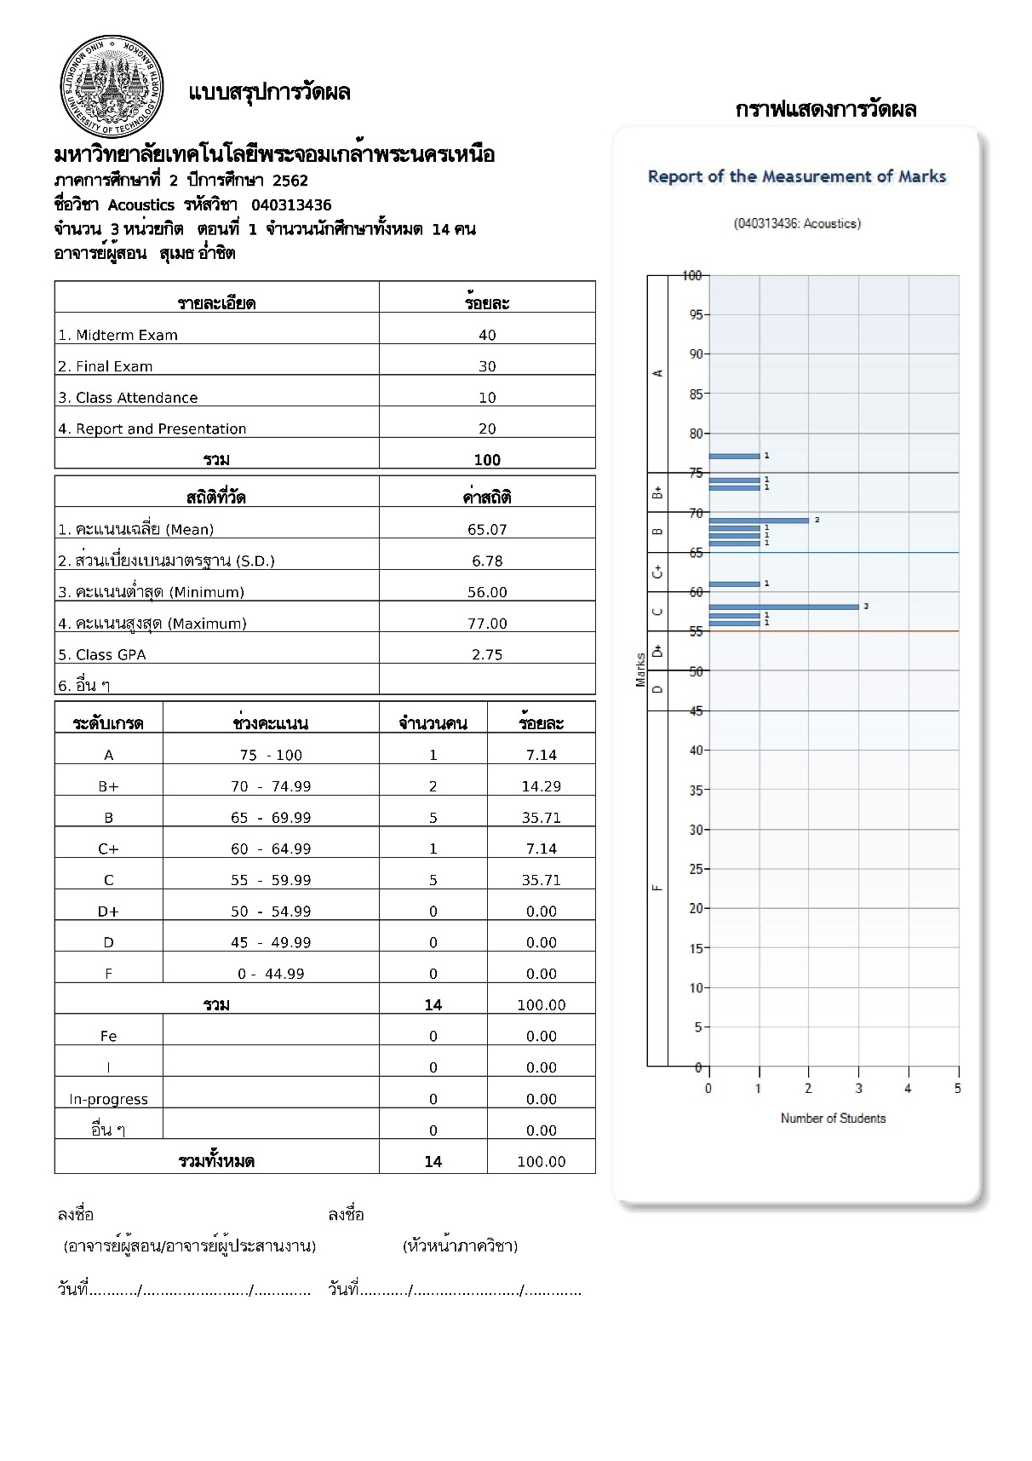
2. Factors affecting unusual patterns of assessment results. (If any)
......................................................................................................................................................................................................................................................................................................................................................................................................

Section 5: Assessment of Internship experiences

1. Assessment of internship experiences by student interns
Important comments | Opinions on comments from the instructor/ advisor

2. Internship evaluation by the enterprise/ the mentor
Important comments | Opinions on comments from the instructor/ advisor

Section 6: Improvement Plan

1. Implementation for improvement of earlier internship programs
Improvement plan | Improvement actions | Justification (in case the actions are not completed/ not performed)
- successfully performed
- not performed
- performed, but not completed
- successfully performed
- not performed
- performed, but not completed
- successfully performed
- not performed
- performed, but not completed

2. Other improvement actions carried out towards a more successful intern program in that semester
............................................................................................................................................................................................................................................................................................................................................................................................................3. Suggestions to improve internship programs in the succeeding semester/ academic year.
............................................................................................................................................................................................................................................................................................................................................................................................................

4. Administrative issues and suggestions
4.1 Administrative problems of the university/ enterprises / workplace (if any)
............................................................................................................................................................................................................................................................................................................................................................................................................
4.2 Impacts on student learning ............................................................................................................................................................................................................................................................................................................................................................................................................

4.3 Necessary modifications to overcome challenges associated with future internship

.......................................................................................................................................................................................................................................................................................................................................................................................................

Instructor in charge/ Internship faculty advisor
Signature.................................................
Date of Report................................................

Program Director
Signature..............................................................................
Date of Report......................................................................

Instruction for OBE 6 Preparation

Section 1: General Information

Topic | Description
1. Course code/ title | XXXXXXXXX Course title (Thai and English)
2. Number of credits | Credits (Lecture/Practice/Self-study Hours)
3. Course category | Specify the program of study and course classification  e.g. a general core course (for several disciplines), mandatory, major, electives, specific elective categories
5. Semester / year of study | Specify semester/ year of study according to the curriculum planning
8. Information for quality assurance in education | Put check marks (Tick ✓) in the appropriate boxes

Section 2: Course Learning Outcomes

Topic | Description
Course Learning Outcomes: (CLOs) | CLOs are required to be consistent with OBE 3 Section 2.4

Section 3: Course Implementation
Topic | Description
1. Implementation outcomes for learning efficiency | A. Specify whether the implementation process, i.e. preparation of relevant parties (students, advisors, supervisors and mentors) is consistent with the plan, or any alterations occur. Provide recommendations for improving program implementation  B. Define the results of support arrangement to facilitate effective learning. Indicate whether the implementation is in line with the plan. Identify improvement guidelines
2. Any changes of the implementation process, compared with the original plan in OBE4 | Indicate whether the implementation of internship experience is consistent with the plan. Define positive or negative effects and provide guidance.
3. Learning outcome evaluation system | Define evaluation methods; indicate whether an assessment plan has been established; suggest developing guidelines

Section 4: Overview of Evaluation Results
Topic | Description
1. Evaluation outcomes | Capture the screenshot of online grading overview and teacher evaluation form)
2. Factors affecting grading discrepancies, if any | Define factors contributing to grading discrepancies, compared to those in earlier semesters

Section 5: Evaluation of Internship Training
Topic | Description
1. Internship evaluation by students | Specify critiques, both the strong points and weak points; exhibit opinion of the instructor in charge/ advisor on the critiques.
2. Internship evaluation by workplace/ mentor | Specify critiques from the stated evaluation outcomes, both strengths and weaknesses. Reveal opinions and responses of the responsible instructor/ advisor.

Section 6: Improvement Plan
Topic | Description
1. Implementation/ progress of former program development | Identify a development plan and implementation outcomes. Give a justification in case the plan is incomplete or has not been carried out.
2. Other actions to improve the internship program in that semester | Suggest other implementation activities for enriching internship experience during that semester.
3. Suggestions for a development plan for subsequent semester or academic year | Recommend a plan for improving program implementation for subsequent semesters/ academic years
4. Issues with managing an internship program and suggestions | Indicate significant issues/ impacts and suggestions (if any problems occur)

