Report on Course Implementation

Name of Institution King Mongkut's University of Technology North Bangkok
Campus/Faculty/Dept/Division ………………………………………………………….………………………

Section 1: General Information
1. Course code and course title ..................................................................................................................................................
2. Total credits X (x-x-x)
........... X credits (x-x-x) ......................................................................................................
3. Curriculum and course category:
Curriculum: e.g. (Bachelor of ………in ……) ………………………………
Course category: (e.g. general education, required, major elective, free elective)
4. Course coordinator/ Instructors
Course coordinator ..............................................................................
Instructors ..............................................................................
5. Semester/ year of study
……………………………………………………………………………….
6. Pre-requisite (if any)
………………………………………………………………………………
7. Co-requisites (if any)
……………………………………………………………………………….
8. Venue of study
Faculty/ College ........................................................................................ KMUTNB
9. Information for quality assurance in education
This course shows evidence of:
Development of implementation from previous practices, e.g. the improvement of
class teaching, course content, content classification and methods used for learning
assessment
Involvement from professional bodies/ external agencies in instruction; thus enhancing
student academic and professional experiences
Integration of research or creative activities with instruction; use of research-based
learning management; knowledge management practices for learning improvement
Integration of academic services and course implementation
Combination of cultural heritage preservation efforts into instruction or student
activities
10. Date of latest revision
……………………………………………………………………………….
Section 2: Teaching Implementation in relation to Planning
1. Specify whether discrepancies occur between actual teaching hours and planned hours. ..........……………………………………………………………………………………………………………………………………………………………
2. Define topics uncovered/ uncompleted (if any)
.........……………………………………………………………………………………………………………………………………………………………
3. Report on the support provided for enhancing learning effectiveness
Support domains | Implementation outcomes
 | Being carried out | Not carried out | Improvement plan
- Preparing up-to-date teaching documents | Indicate the academic year of latest revision
2. information technology | Indicate the IT system used for enhancing instructional efficiency
- Problem acknowledgement scheme | Explain
- Student counseling
- Others (specify)
4. Course Learning Outcomes (CLOs):
Students should be able to: (Please refer to OBE section 2.4)
CLO 1. Explain …………………
CLO 2. Analyze ………………….
CLO 3. Solve problems …………
CLO 4. Apply………………………
CLO 5. Perform……………………..
(Items can be included or deleted as appropriate)
5. Effectiveness of teaching methods and evaluation that leads to predetermined learning outcomes, as referred to in OBE3 section 3
Course Learning Outcomes (CLOs) | Determining  CLOs Achievement  (Yes/ No)  (Tick ✓) | Teaching methods/ implementation on the basis of CLOs | Appropriateness of teaching methods  (Yes/ No)  (Tick ✓) | Evaluation of learning outcomes based on CLOs | Appropriateness of evaluation  (Yes/ No)  (Tick ✓) | Development guidelines to ensure student attainment of CLOs; suggestions for effective implementation and evaluation
CLO1 | x | Lecture-based learning, case studies, assignments | x | - Midterm examination  - Assignment assessment |  | Issue 1:  Thirty percent of students are unable to interpret variance analysis results  Problem based-improvement , according to the cause, issue 1  - Assigning tasks to students so they can appropriately interpret analysis of variance results; conducting more assessments on the issue  - Placing a focus on interpreting the results of ANOVA  - implement question and answer sessions in the classroom to check students’ comprehension  Issue 2:  Thirty percent of students are able to transform data provided into mathematical equations, but they cannot solve the equations correctly.  Problem based-improvement , according to the cause, issue 2  - Review of the foundations of mathematics needed by students  - Supplementary assignments related to mathematical problem solving and applying mathematics
CLO2 |  | Project-based learning) |  | - Assessing group presentations and group projects  - Assessing assigned exercises |  | Issue 1:  Twenty percent of students are still unable to effectively deliver presentations in front of the class; class presentation cannot meet teacher expectations  Problem based-improvement  Teachers create a class presentation rating rubric, which should be distributed to students no less than 2 weeks before the speech delivery.
CLO 3 |  | Group discussion, project presentation |  | - Using peer assessment to evaluate teamwork  - Teacher’s monitoring group work activities
N.B.
- Teachers are able to demonstrate at least one problem that arises through the course of each semester; for instance, students could not attain the CLO according to the specified criteria; or students encountered certain issues related to their learning experiences.
- For consecutive semesters, teachers are able to define problems and use problem solving approaches to generate a solution.
* The Department specifies criteria to determine the percentage of students who fulfilled the criteria for each CLO.

Section 3: Learning Outcome Evaluation

- Is there a Formative Evaluation?
Yes (Please add details in the table) No
Implementation of Formative Evaluation | Is there a plan? |  | Quality development guidelines
 | Yes | No
a. A well-defined evaluation period
b. Tools/ approach for evaluation. Please specify….
e.g. quizzes, questioning in the classroom, homework assignments
c. Feedback provided to individual student (specify)……………………....................................
d. Use of evaluation results for student development
2. Summative Evaluation

Standards and quality assurance for learning outcomes assessment
Assessment practices | Is there any Implementation? |  | Quality development guidelines
 | Yes | No
- Examination
a. Setting a table of specification
b. Exam review before usage
c. Exam analysis
d. Creating test banks
- Developing a scoring rubrics for assessment
- Establishing clear evaluation criteria
4. Applying a qualified, standards-based grading system
- Criterion-referenced assessment
- Norm-referenced systems assessment
- Others, specify .............
5. Validation of assessment and learning outcomes

Section 4: Overview of Assessment Results

1. Course Evaluation outcomes. Capture the screenshot from the measurement report summary page. Here is an example:
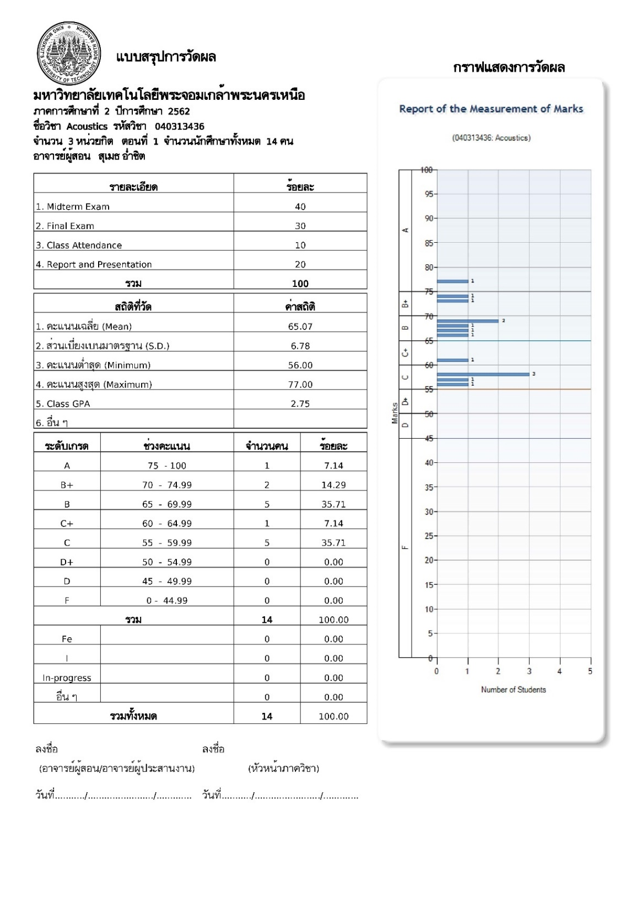
2. Contributing factors to grading discrepancies. (If any)
.........………………………………………………………………………………………………………………………………………………………………………………………………………………………………………………………………………………………………………………………………………………………………………………………………………………………………………………………………………

3. Discrepancies from the evaluation plan as outlined in Course Specification, e.g. incongruities of time frame and assessment methods
Learning Outcomes | Method of evaluation |  | Week of evaluation |  | Weighting of evaluation
 | Planned | Actual | Planned | Actual | Planned | Actual

4. Verification of students’ learning outcomes, as referred to in OBE 2 and 3
- Setting up a committee to inspect students’ learning outcomes, e.g. an investigation of examination, grading practices and performance appraisal
- Review of students’ scoring and evaluation by the Faculty/ Department academic committee
- Randomized scoring validation, whereby experts/ faculty not responsible for the curriculum perform random checks of students work
- Others (specify)……………………….

Section 5: Problems and Effects on Course Implementation

1. Problems associated with resources availability, equipment and facilities (if any)
.........…………………………………………………………………………………………………………………………………………………………………………………………………………………………………………………………………………………………………………………………………

2. Management and administrative challenges (if any)
.........…………………………………………………………………………………………………………………………………………………………………………………………………………………………………………………………………………………………………………………………………

Section 6: Course Evaluation

1. Course evaluation results by students (Please attach documents)
1.1 Key comments from student evaluation results
.........…………………………………………………………………………………………………………………………………………………………………………………………………………………………………………………………………………………………………………………………………

1.2 Lecturer responses/ opinions on the issues raised in 1.1
.........…………………………………………………………………………………………………………………………………………………………………………………………………………………………………………………………………………………………………………………………………

2. Results of course evaluation from other evaluation methods
2.1 Key comments from other evaluation methods
…………………………………………………………………………………………………………………………………………………………………………………………………………………………………………………………………………………………………………………………………………
2.2 Lecturer responses to the issues raised in 2.1
…………………………………………………………………………………………………………………………………………………………………………………………………………………………………………………………………………………………………………………………………………

Section 7: Improvement Plan

1. Actions for improvement (Other than those specified in Section 2)
Example:
- A 360-degree assessment conducted by students is recommended. Respondents are encouraged to offer ideas and suggestions.

-Take advantage of IT-based integration assessment, e.g. using Google Forms to create digital rubrics for student feedback

2. Suggestions for improvement from course instructors to faculty in charge of the curriculum
.........………………………………………………………………………………………………………………………………………………………………….....……………………………………………………………………………………………………………………………………………………………

Instruction for OBE 5 Preparation
Section 1: General Information
Topic | Description
1. Course code/ title | XXXXXXXXX Course title (Thai and English)
2. Prerequisite | XXXXXXXXX Course title (Thai and English)
3. Coordinator, instructors, sections | Dividing into sections
5. Semester / year of study | Indicate semester / year of study, following the curriculum planning.
8. Venue of study | Define on and off-campus learning locations.
10. Information for educational quality assurance | Check marks (Tick ✓) in appropriate boxes.

Section 2: Class Implementation in Comparison with the Designed Lesson Plan
Topic | Description
1. Number of actual teaching hours compared to those stated in the lesson plan | Provide topics and number of intended teaching hours and actual teaching hours. State justification if the disparity exceeds 25%.
2. Topics that were not covered as planned | Identify topic(s) that were not completed as planned and significant effects on learning outcomes. Suggest alternatives to remedy the issue.
3. Providing support for learning effectiveness | Explain, e.g. providing handouts, utilizing information technology; arrangement of problem acknowledgement and student counseling practices. Define an improvement plan if no action has been taken.
4. Course Learning Outcomes (CLOs) | Outline CLOs in compliance with OBE3 section 2.4
5. Effectiveness of learning implementation and evaluation methods carried out as to achieve the specified CLOs | Indicate methods of learning implementation to achieve each CLO domain; explain evaluation methods implemented as specified in OBE3 section 3; state whether CLOs can be attained and whether the implementation is appropriate. Suggest development guidelines for learning implementation and evaluation.

Section 3: Learning Outcome Evaluation
Topic | Description
1. Formative Evaluation | Formative evaluation for learning involves a continuous way of monitoring with aims to improve teaching and student attainment. Formative assessment instruments are e.g. a test, a quiz, questions and homework.  - Indicate the applicable evaluation process and development guidelines.
2. Summative Evaluation | Summative evaluation aims at evaluating student learning and understanding at the end of an instructional unit, e.g. midterm and final examinations.  - Indicate the applicable evaluation process and development guidelines.

Section 4: Overview of Assessment results
Topic | Description
1. Measurable learning outcome after implementing and completing a course | Capture the screenshots (summary grade report online and evaluation of teaching).
2. Factors causing the disparities in grade distributions (If any). | Identify the factors, compared with grade distribution of previous classes.
6. Discrepancies (in time frame / evaluation methods) between planned and actual assessment (If any). | Identify discrepancies from evaluation plan as indicated in course specification (OBE3) Section 4.2
7. Verification of student’s achievement | Clarify the verification process as established in OBE3, section 6.4

Section 5: Implementation Challenges and Impacts
Topic | Description
1. Problems relating to educational resources | Identify problems and effects upon student learning
2. Management issues | Identify issues and impacts on learning

Section 6: Course Evaluation
Topic | Description
1. Critical comments from student evaluation | Identify both positive and negative aspects
2. Critical comments from other evaluation methods | Identify both positive and negative aspects

Section 7: Improvement Plan
Topic | Description
1. Actions for improvement of learning and teaching | Briefly identify improvement methods e.g. changing of teaching methods in the semester; use of new types of instructional resources to improve student attainment of learning outcomes.

